**Oracle 12c RDBMS Installation**

**-------------------------------------------------------------------------------------------------------------**

**Platform :** Red Hat Enterprise Linux Server release 6.4 (Santiago)

**Architecture :** x86_64

**Cluster Nodes :** scrbusidkcph021, scrbusidkcph022

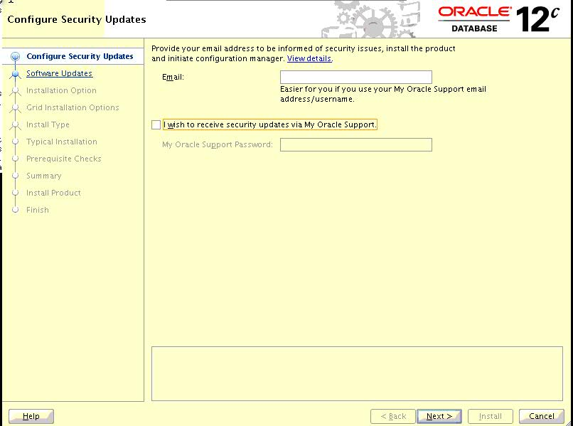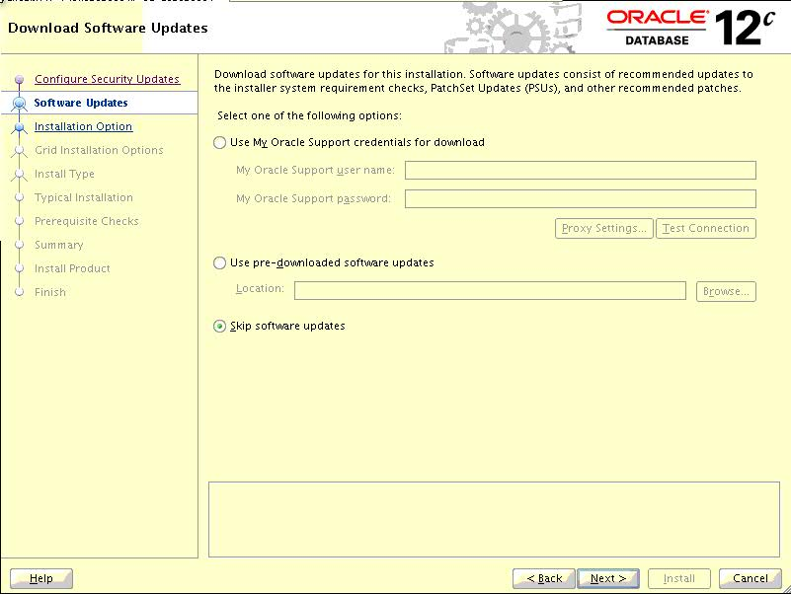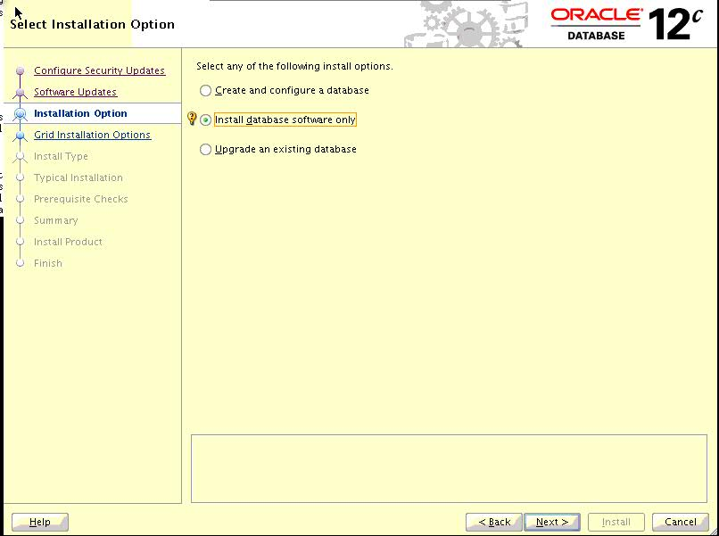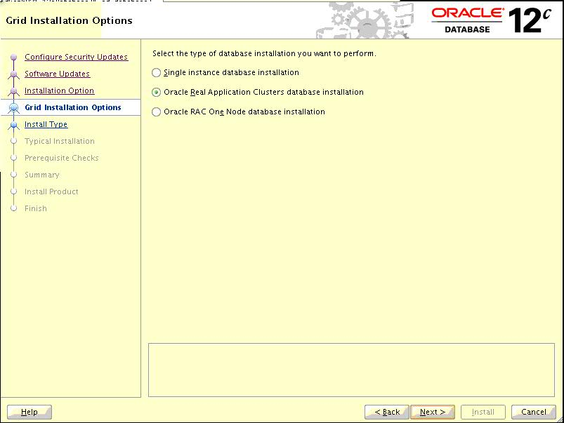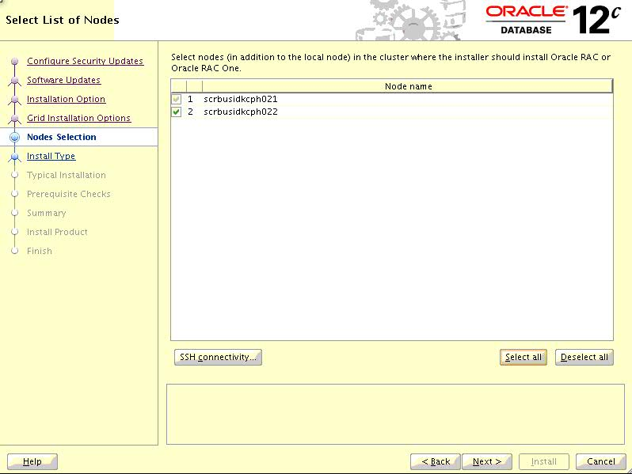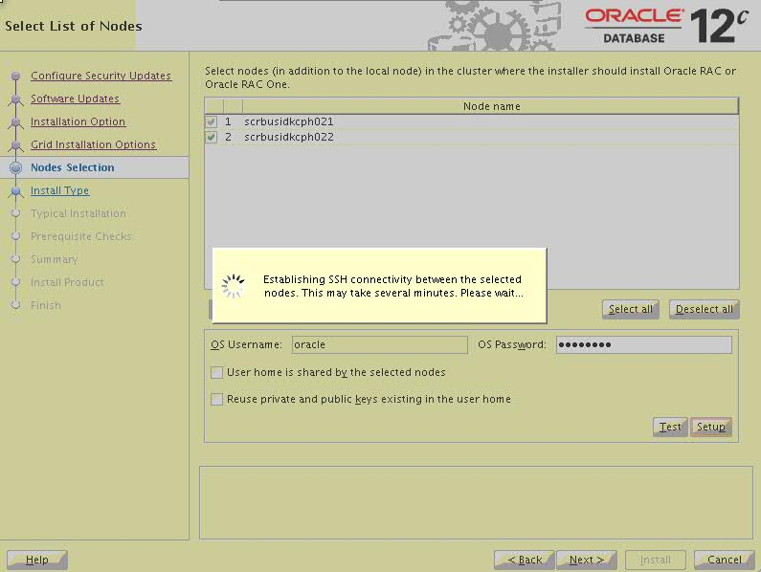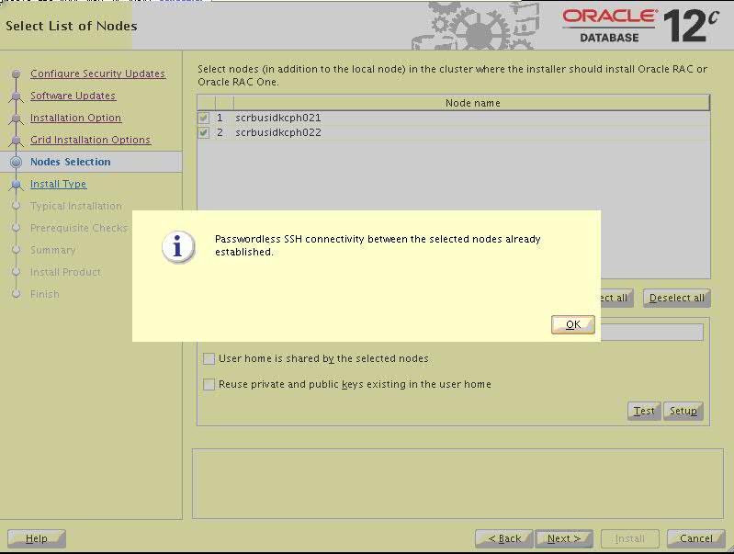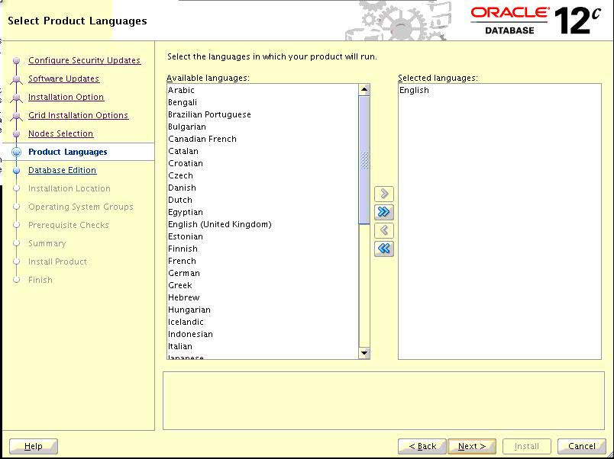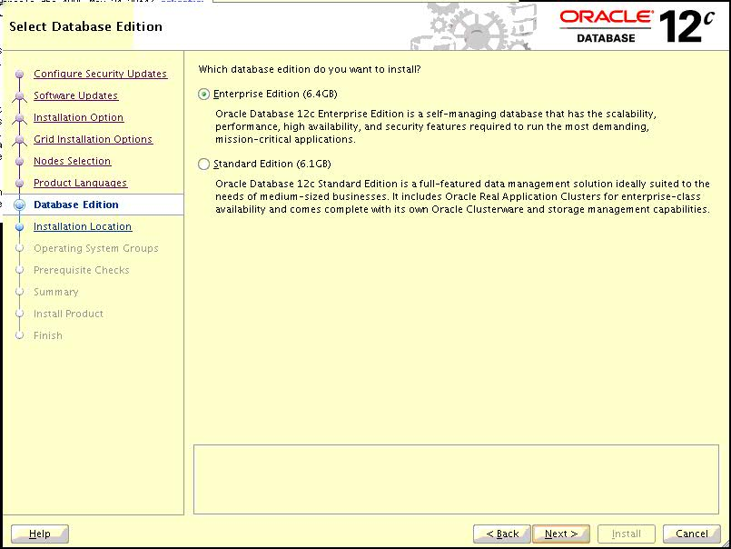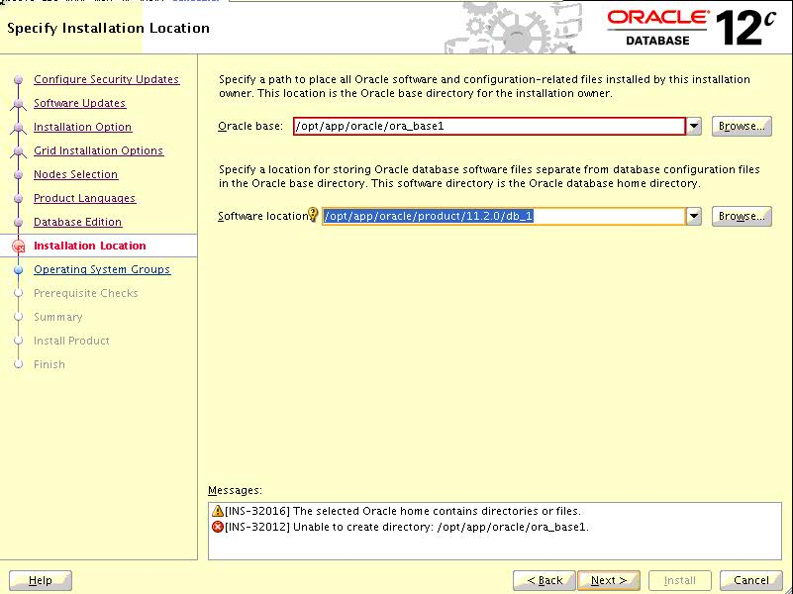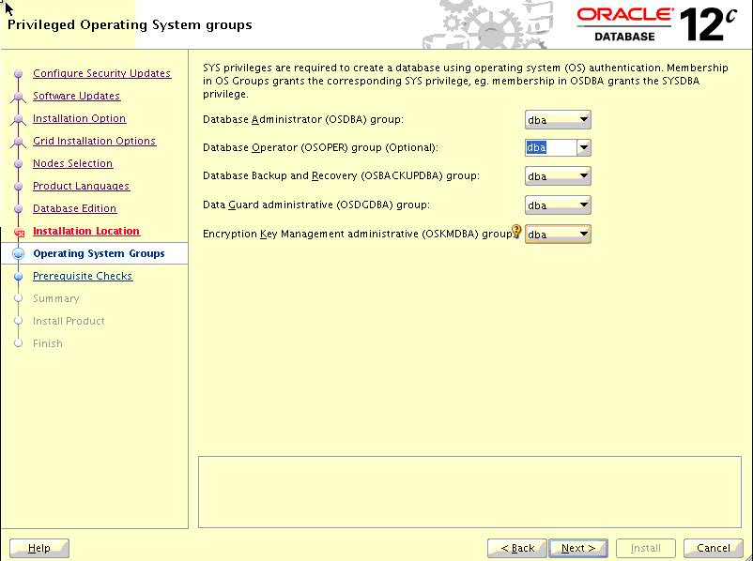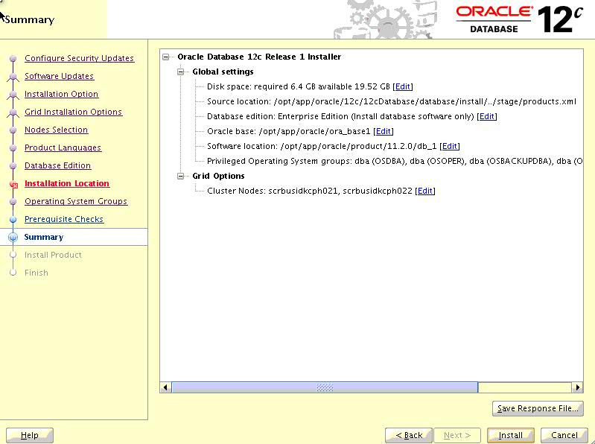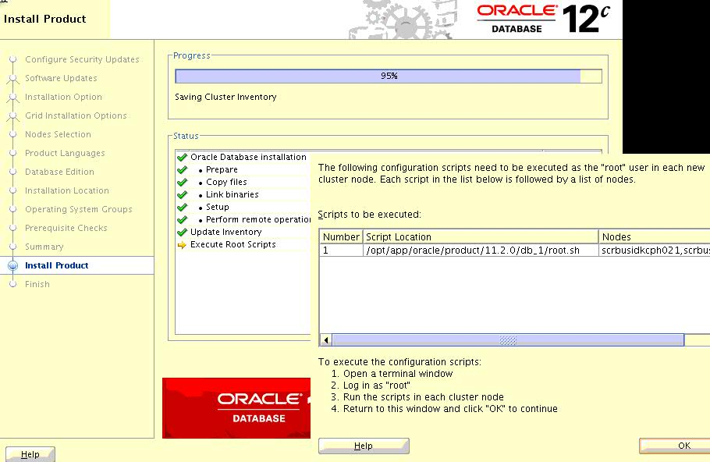

[root@scrbusidkcph022 db_1]# /opt/app/oracle/product/11.2.0/db_1/root.sh

Performing root user operation for Oracle 12c

The following environment variables are set as:

ORACLE_OWNER= oracle

ORACLE_HOME= /opt/app/oracle/product/11.2.0/db_1

Enter the full pathname of the local bin directory: [/usr/local/bin]:

The contents of "dbhome" have not changed. No need to overwrite.

The contents of "oraenv" have not changed. No need to overwrite.

The contents of "coraenv" have not changed. No need to overwrite.

Entries will be added to the /etc/oratab file as needed by

Database Configuration Assistant when a database is created

Finished running generic part of root script.

Now product-specific root actions will be performed.

[root@scrbusidkcph022 db_1]#

[root@scrbusidkcph021 ~]# /opt/app/oracle/product/11.2.0/db_1/root.sh

Performing root user operation for Oracle 12c

The following environment variables are set as:

ORACLE_OWNER= oracle

ORACLE_HOME= /opt/app/oracle/product/11.2.0/db_1

Enter the full pathname of the local bin directory: [/usr/local/bin]:

The contents of "dbhome" have not changed. No need to overwrite.

The contents of "oraenv" have not changed. No need to overwrite.

The contents of "coraenv" have not changed. No need to overwrite.

Entries will be added to the /etc/oratab file as needed by

Database Configuration Assistant when a database is created

Finished running generic part of root script.

Now product-specific root actions will be performed.

[root@scrbusidkcph021 ~]#

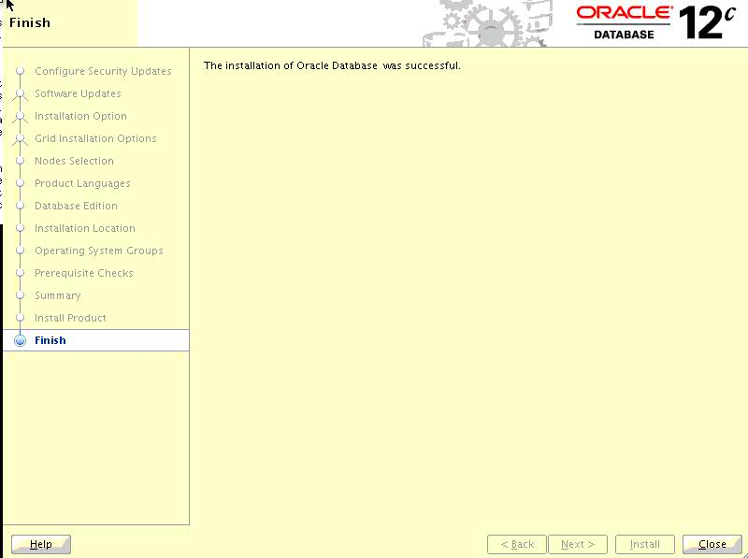

**Oracle 12c RAC Database Creation using DBCA**

**-------------------------------------------------------------------------------------------------------------**

**Platform :** Red Hat Enterprise Linux Server release 6.4 (Santiago)

**Architecture :** x86_64

**Cluster Nodes :** scrbusidkcph021, scrbusidkcph022

**Instance Name :** USIT1, USIT2

**Database Name :** USIT



